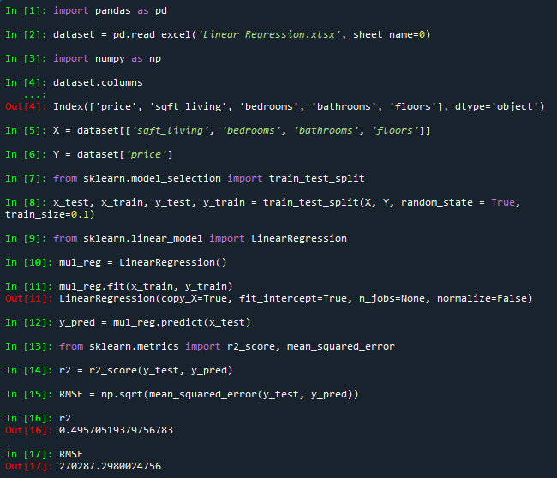

$r^{2}$ value of approximately 0.5 indicates a weak-moderate effect

RMSE of 270,000 is very high though, so, it is not very precise!